Paper dani draft

Results

Mutational Signatures
A mutational signatura análisis was performed using the packages from SigProfiler in R as set to obtain the mutational profiles of the samples in our cohort and to search for a specific group of mutational signatures reported to be correspondent to liver hepatocarcinoma.

The quality of the reconstructed mutation profile by SigProfilerAssignment was measured by the cosine similarity metric, of which historically there has been inconsistency in the assignment of a threshold for a good quality reconstruction, albeit the selection of a threshold score between 0.75 and 0.8 is commonly reported for reconstructions based on reported mutational signatures and a score of 0.75 or less is commonly selected for de novo mutational signatures (https://journals.plos.org/plosone/article?id=10.1371/journal.pone.0221235). In our reconstruction the distribution of the cosine similarity of the samples approximates to a normal distribution where the mean is position at a cosine similarity score of 0.85, which stands above the stablished quality standard for this metric.
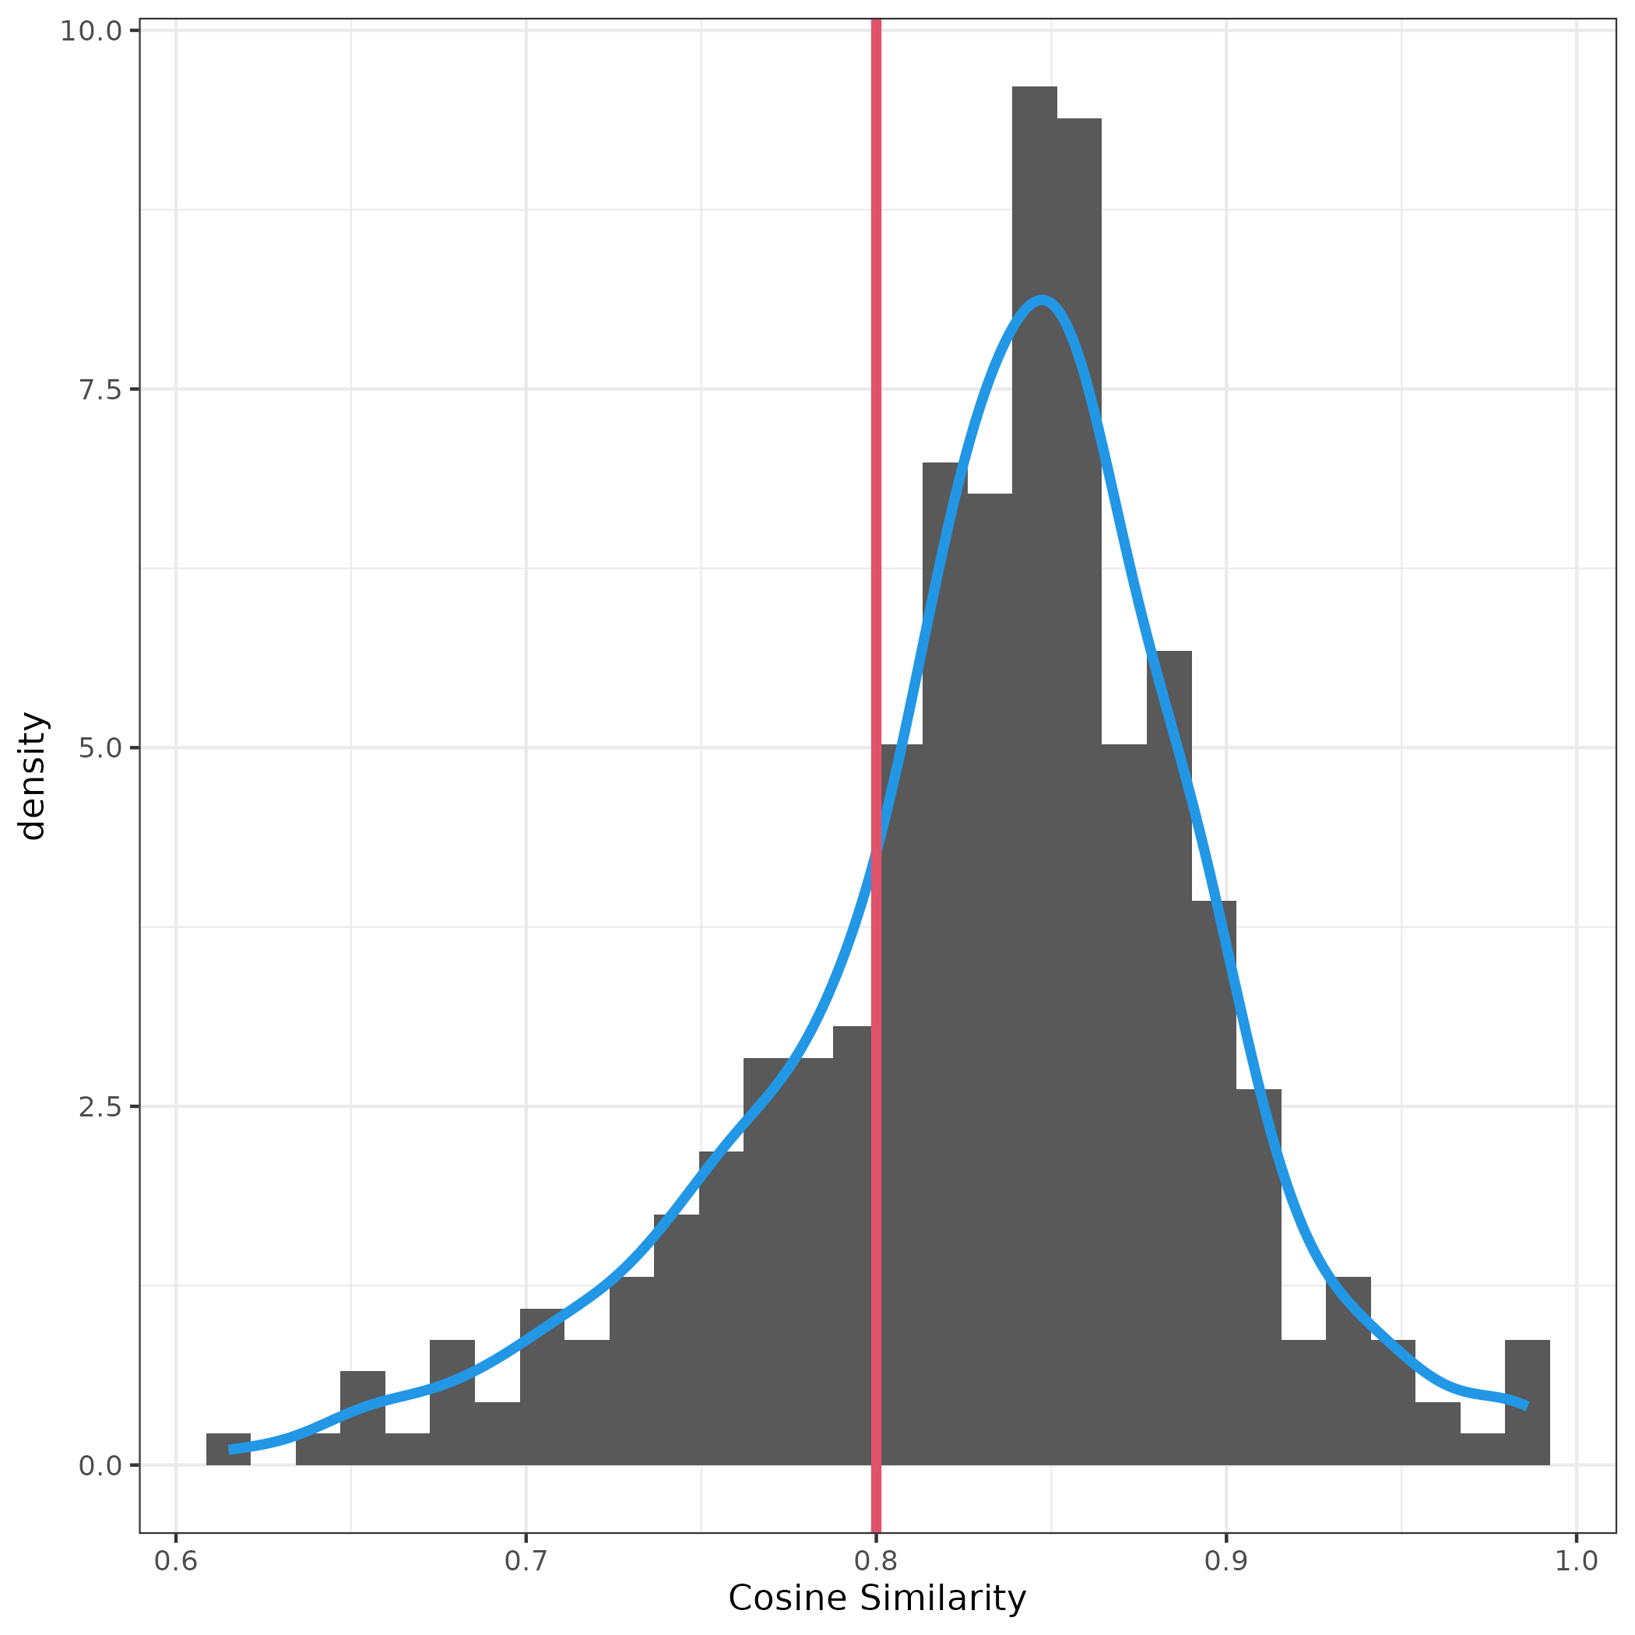

Mutational signatures in driver genes

Discussion

Mutational Signatures

Mutational signatures in driver genes

